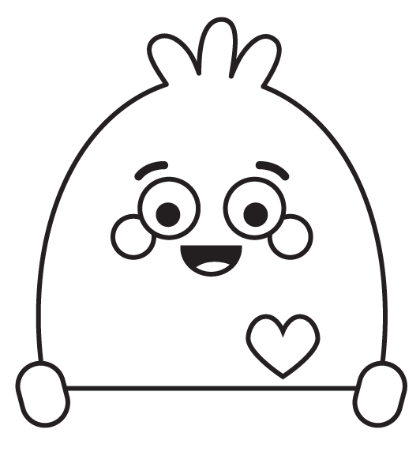 | Part 1: Directions  Use the sentence stems and emojis to help you come up with five tips for practicing active listening at school.

💡Tips for Active Listening👂 | Emoji 😃
When I am using a device, I can show that I am actively listening by…

When I am using a device, I can show that I am actively listening by…

When I see someone speaking or trying to get my attention, I should…

When my teacher is giving instructions I should…

If I don't understand what someone said, I should…

Part 2: Crossword Puzzle
Step 1: Use the word bank to help you fill in the clues.
Step 2: Use the clues to complete the crossword puzzle!

✏️ Word Bank ✏️
Distraction  Feelings | Listen  Respect | Tone

Across |  |  |  |  | Down
1. | A |  | is anything that makes |  | 3. | When you |  | , you give your full
 | you lose focus on what you need to do. |  |  |  |  | attention to someone who is talking.
2. | Your |  | of voice can |  | 4. | Showing |  | is when you act in a
 | communicate whether you are happy, angry, |  |  |  |  | way that shows you care for others.
 | or sad. |  |  |  | 5. | Our actions can impact other people's
 |  |  |  |  |  |  |  | .

 |  |  |  |  |  |  |  |  | ^{4.} |  |  |  | ^{5.}
 |  |  |  |  |  | ^{3.}
 |  |  | ^{1.}
 |  |  |  | ^{2.}

