Is Seeing Believing?

Name:
Date:

Example 1: Directions
Work with your group to analyze the photograph on this page. Then answer the questions below.

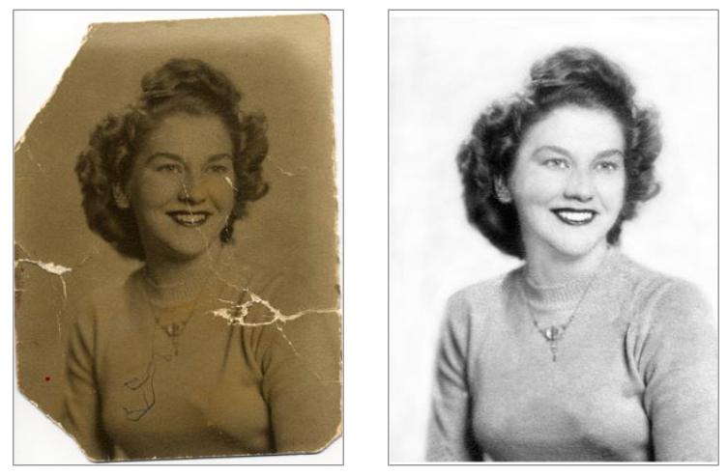

- What was altered in the second version of the photo?

- Why do you think it was altered? What was the person who altered it trying to accomplish?

Example 2: Directions
Work with your group to analyze the photograph on this page. Then answer the questions below.

- What was altered in the second version of the photo?

- Why do you think it was altered? What was the person who altered it trying to accomplish?

Example 3: Directions
Work with your group to analyze the photograph on this page. Then answer the questions below.
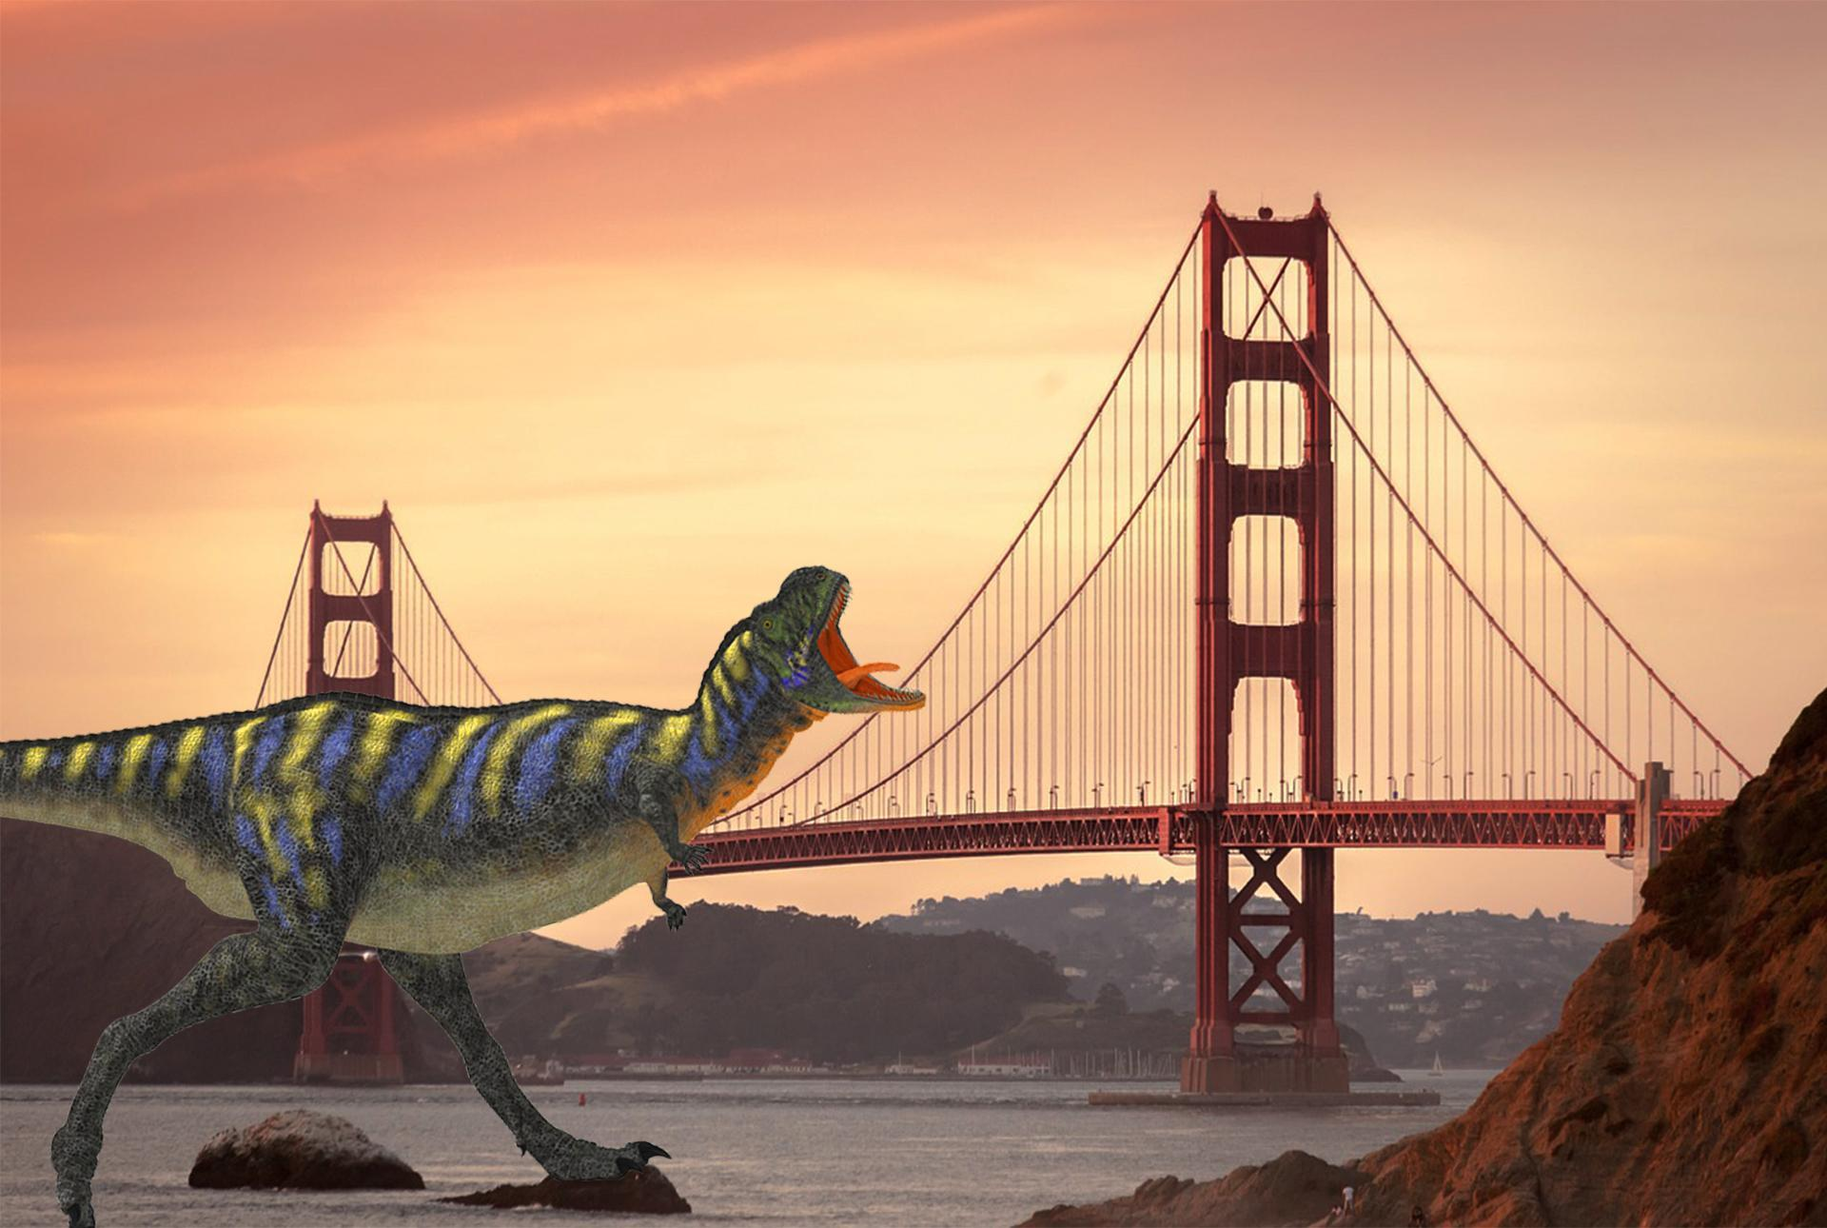

- How was this photo altered?

- Why do you think it was altered? What was the person who altered it trying to accomplish?

Example 4: Directions
Work with your group to analyze the photograph on this page. Then answer the questions below.

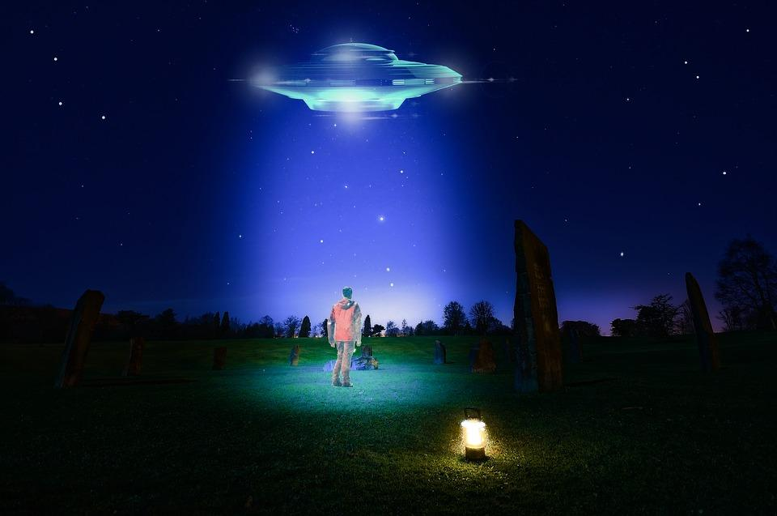

- How was this photo altered?

- Why do you think it was altered? What was the person who altered it trying to accomplish?

