Directions
Read the story below and then work with a partner to answer the questions that follow.
Rani loves a website where she can play in a virtual world and chat with other players. Lately, Rani has been playing in a new area. She started receiving some mean messages from the other players.
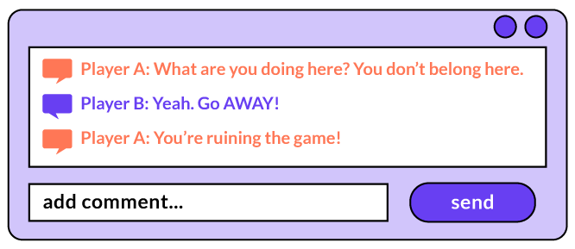

1. How would you feel if you were Rani reading those messages? I would feel ...

2. Why do you think people send these kinds of messages to people they don't know? People send these kinds of messages because ...

3. What advice would you give Rani to respond to this situation? Remember S-T-O-P.

