Reading News Online

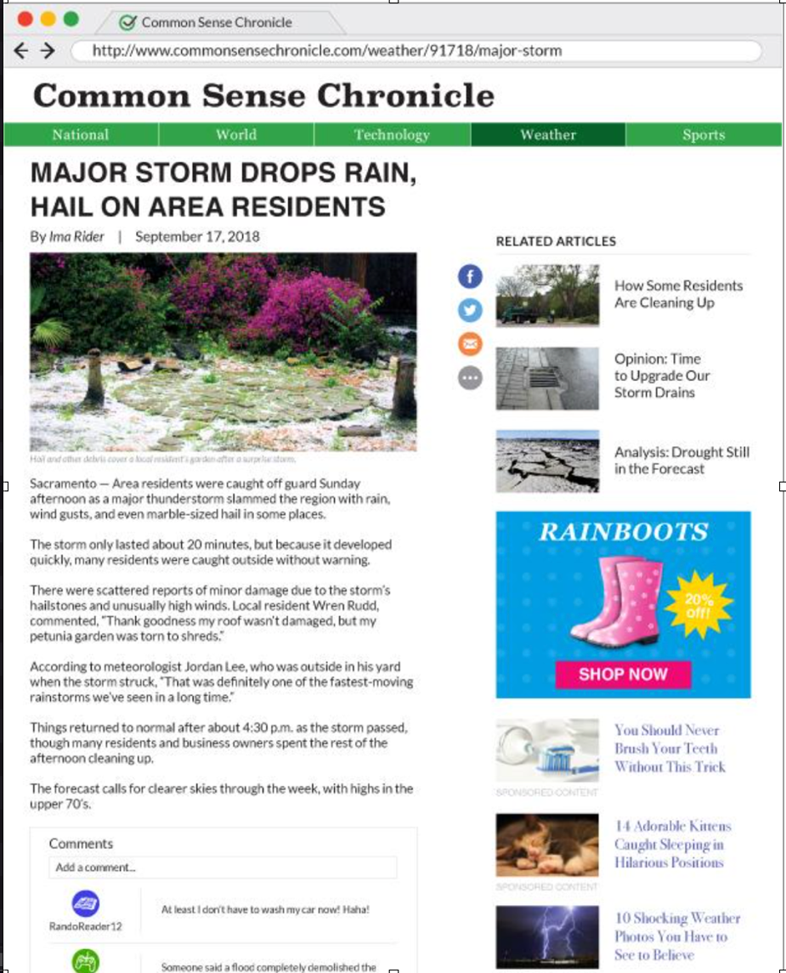
Name: Date:

