Avoiding Click Bait!

Name:

Date:

Directions: Part 1
Use the clues below to identify which examples are clickbait, where the main purpose is to get you to click.
- Clue #1: It seems impossible or unbelievable.
For example, "Think Your Cat Loves You? It's Actually Plotting to Make You Sick."
- Clue #2: It tries to shock you.
For example, "You Won't Believe This!" or "The Answer is Genius!"
- Clue #3: It refers to a celebrity or popular topic.
For example, "Kylie Jenner Uses This Food Item for Luscious Hair: You Won't Believe What It Is!"
1.  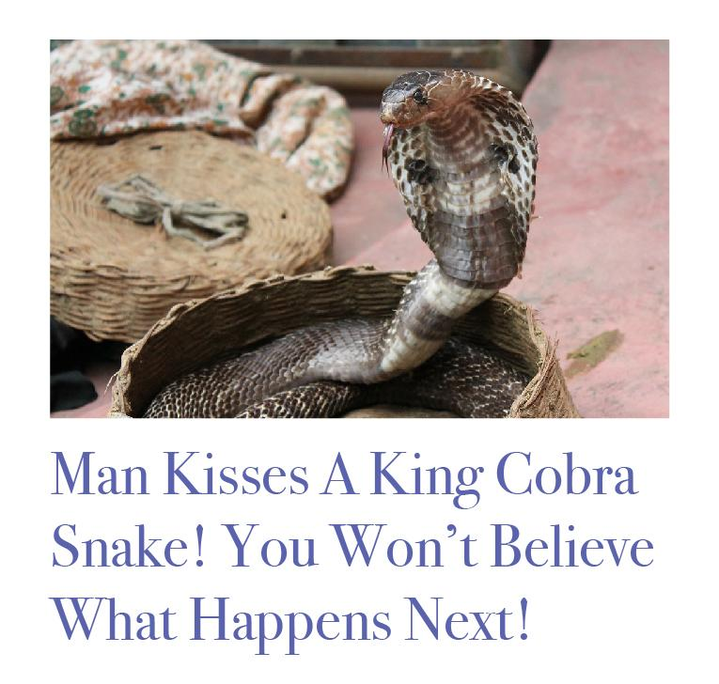 |  |  | 2.
Is it clickbait?  Highlight up or down. |  |  | Is it clickbait?  Highlight up or down.
Why, or why not? |  |  | Why, or why not?

3. |  |  | 4.  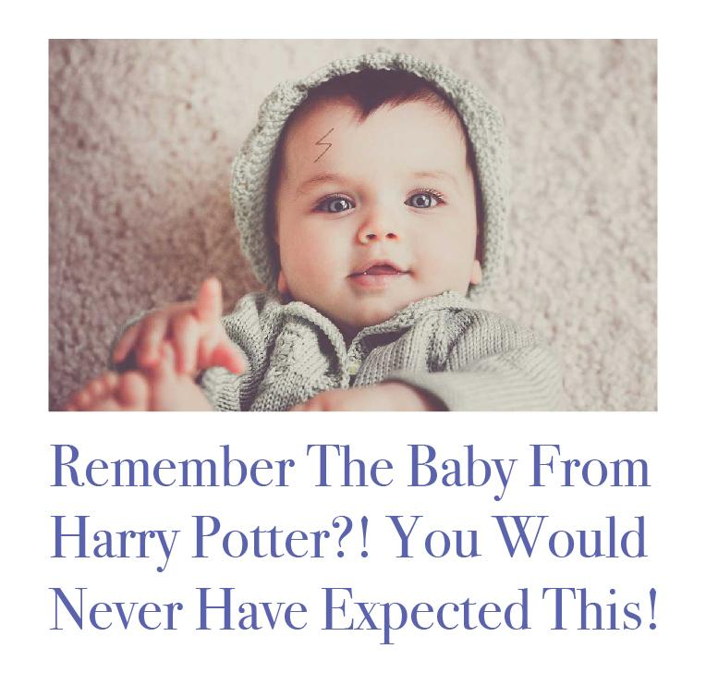
Is it clickbait?  Highlight up or down. |  |  | Is it clickbait?  Highlight up or down.
Why, or why not? |  |  | Why, or why not?

Directions: Part 2
In the space below, write a clickbait headline of your own. Remember to use the clues from Part 1 and "The Curiosity Gap" to help you! If you have time, draw or insert an image next to it.

